WEB APPENDIX A. MANIPULATIONS AND STIMULI IN EACH STUDY
STUDY 1.
Target consumers:
Location: USA & Canada
Female, 18–40
Detailed targeting (demographics, interests, or behaviors):
Fitness & Wellness (body building, physical exercise, physical fitness, running, weight training, yoga)
Hobbies and activities: travel/adventure travel
Sport and outdoors
Timeline: 7 days
Budget: $20/day/ad
STUDY 2.
Manipulation of Nostalgia
Nostalgia Condition
According to the Oxford Dictionary, “nostalgia” is defined as a “sentimental longing for the past.”
Bring to mind a nostalgic event in your life. Nostalgia is experienced when one reminisces about past events that are unlikely to reoccur.
Take some time to think about a past event in your life that makes you feel most nostalgic. Try to recall this event. Then please describe the event and the feelings and thoughts that you have in your written response below.
Control Condition
Bring to mind an ordinary event in your daily life—an event that took place in the last week. This event should not be special or different from other events in your life.
Take some time to think about the ordinary event. Try to recall this event. Then please describe this event and the feelings and thoughts you have in your written response below.
Jean Product Category
Benefit-Focused Appeal
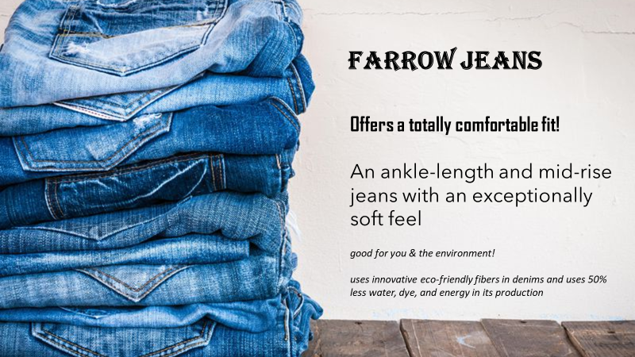

Sustainability-Focused Appeal

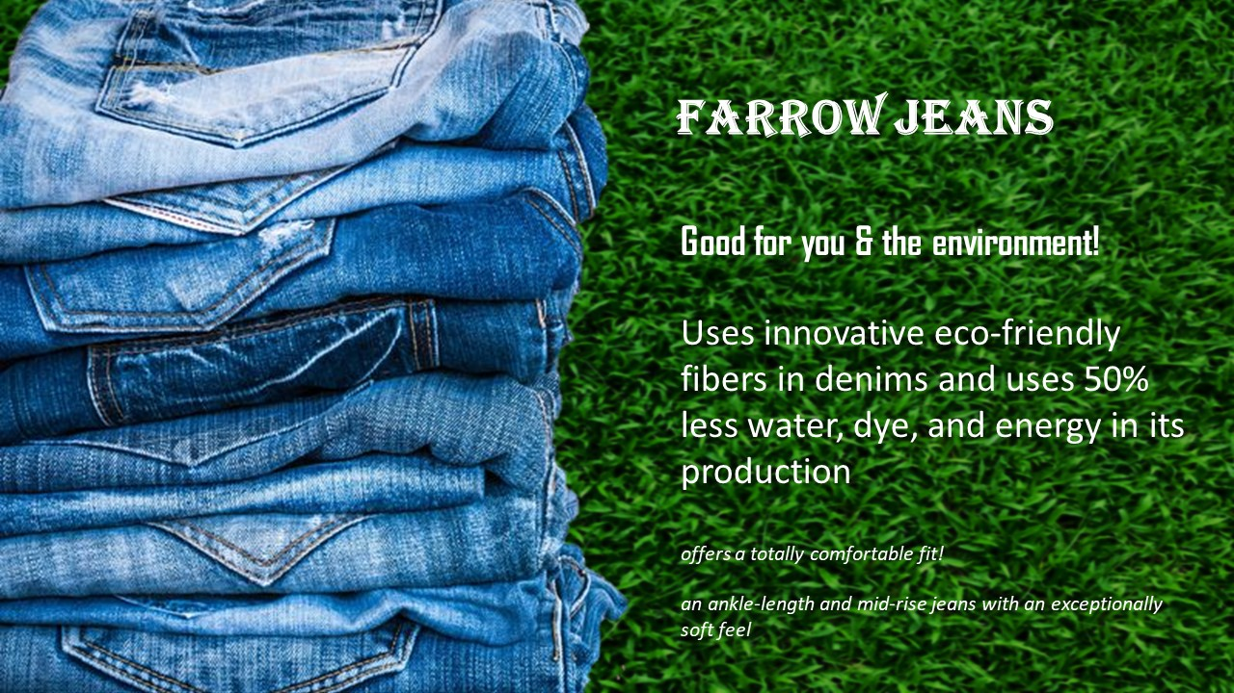

STUDY 3.
Nostalgia Condition
The first part of the survey is called "Photo Essay." You will have 2 minutes to complete this task. After 2 minutes, a "Next" button will appear for you to move to the next question.
According to the Oxford Dictionary, “nostalgia” is defined as a “sentimental longing for the past.”
On your phone or other device, please search for a picture you have taken in the past that you feel nostalgic about. Take a minute to look carefully at the picture. Imagine the occasion in your mind's eye and the person(s), if applicable, in the picture that was taken.
Please list these thoughts below:
- When was the picture taken? (i.e., month and year)
- Description of the occasion and people (if applicable) in the picture.
Please elaborate upon your thoughts and write as much as you can.
- How do you feel when looking at the picture?
Please elaborate upon your thoughts and write as much as you can.
Now please reread what you wrote about when you were looking at that picture, then close your eyes and take a few moments to imagine it.
Control Condition
The first part of the survey is called "Ordinary Event Essay." You will have 2 minutes to complete this task. After 2 minutes, a "Next" button will appear for you to move to the next question.
Bring to mind an ordinary event in your daily life—an event that took place during the last week. This event should not be special or different from other events in your life.
Take a minute to think about this ordinary event. Try to recall it in detail. Then please describe this event and the feelings and thoughts you have in your written response below.
- When did the event take place?
- Description of the event.
Please elaborate upon your thoughts and write as much as you can.
- How do you feel about that event?
Please elaborate upon your thoughts and write as much as you can.
Now please reread what you wrote about your ordinary event, then close your eyes and take a few moments to imagine it.

Running Shoes Product Category
Benefit-Focused Appeal
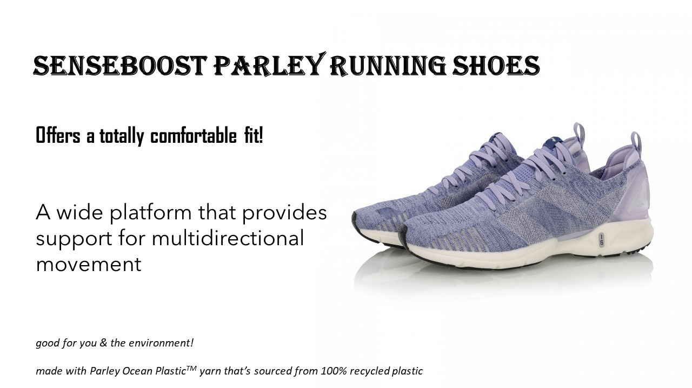
Sustainability-Focused Appeal
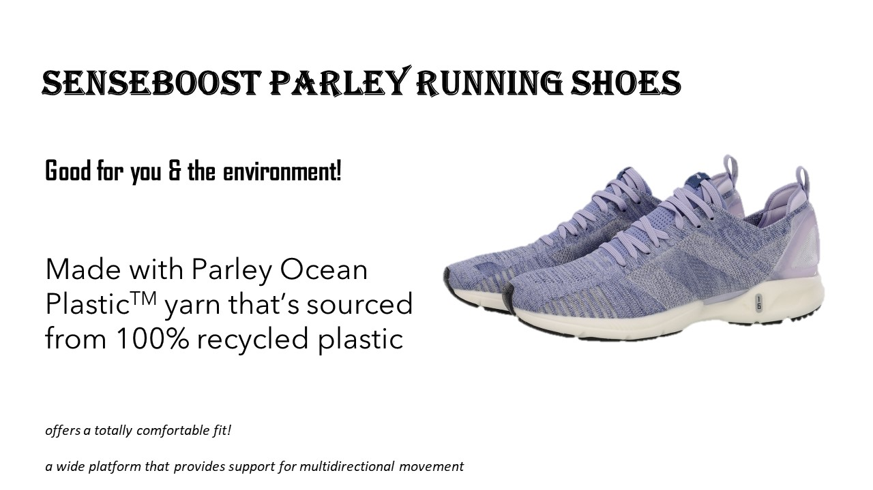

STUDY 4.
Manipulation of Nostalgia
Nostalgia Condition
According to the Oxford Dictionary, “nostalgia” is defined as a “sentimental longing for the past.”
Bring to mind a nostalgic event in your life. Nostalgia is experienced when one reminisces about past events that are unlikely to reoccur.
Take some time to think about a past event in your life that makes you feel most nostalgic. Try to recall this event. Then please describe the event and the feelings and thoughts that you have in your written response below.
Control Condition
Bring to mind an ordinary event in your daily life—an event that took place in the last week. This event should not be special or different from other events in your life.
Take some time to think about the ordinary event. Try to recall this event. Then please describe this event and the feelings and thoughts you have in your written response below.

Activewear Sustainability-Focused Appeal
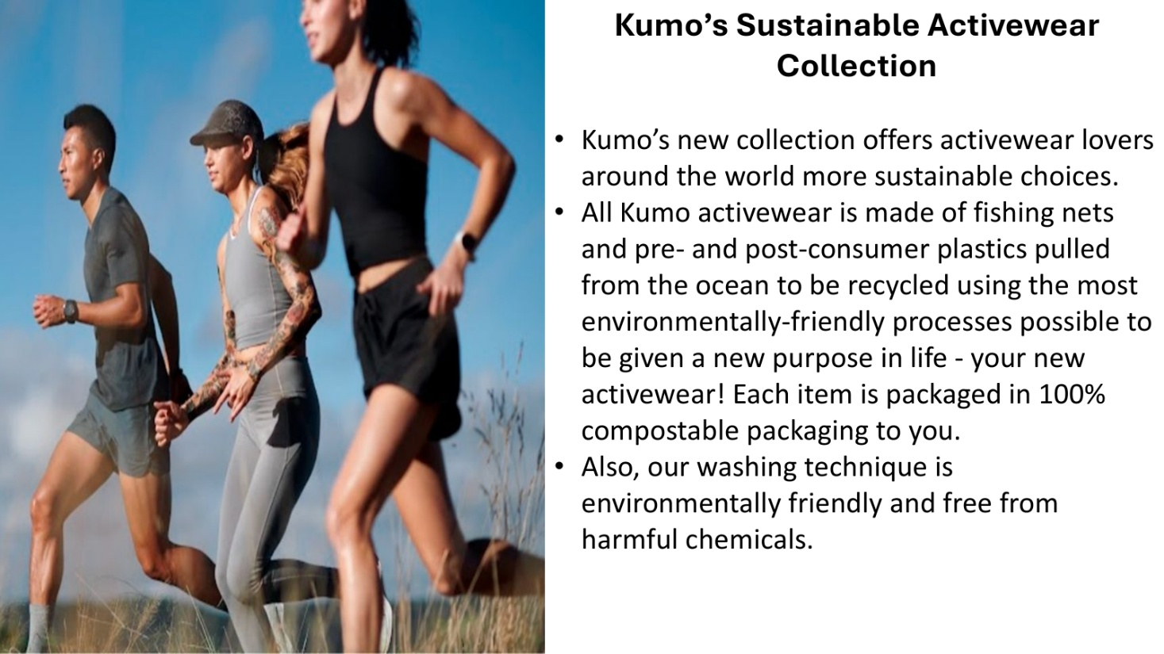
Activewear Benefit-Focused Appeal
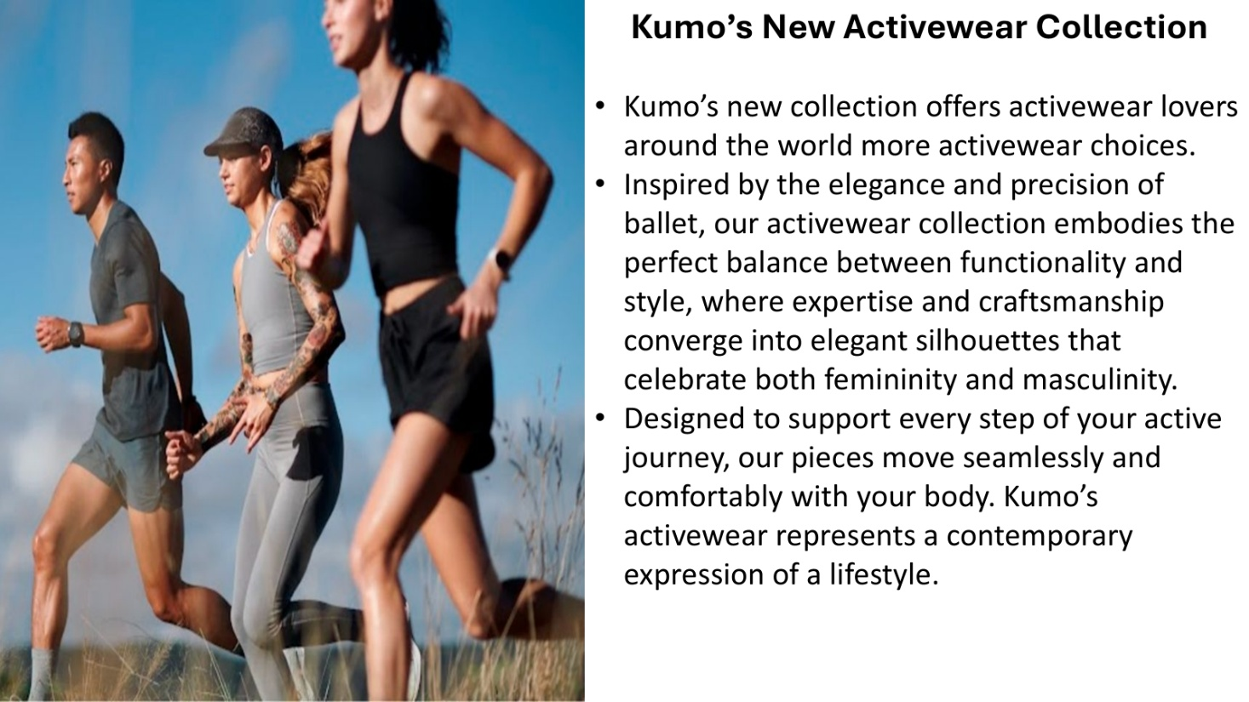
STUDY 5.
Social-Connectedness Condition
Please generate a list of three of the most important people in your life (e.g., family members, friends, partner, or generally close others) that help foster your sense of belonging, such that they make you feel loved, protected, safe, and connected. You are given the space below to elaborate about each person that makes you feel that way.
Person #1.
Please elaborate and write as much as you can about this person such as his/her/their name, how long you have known him/her/them, and why he/she/they makes you feel that you are loved, protected, safe, and connected.
Person #2.
Please elaborate and write as much as you can about this person such as his/her/their name, how long you have known him/her/them, and why he/she/they makes you feel that you are loved, protected, safe, and connected.
Person #3.
Please elaborate and write as much as you can about this person such as his/her/their name, how long you have known him/her/them, and why he/she/they makes you feel that you are loved, protected, safe, and connected.
Now please reread what you wrote.

Baseline Condition
Please list all the food and drink that you have consumed in the past 48 hours. Do not worry about those things you find yourself unable to remember.
Activewear Sustainability-Focused Appeal
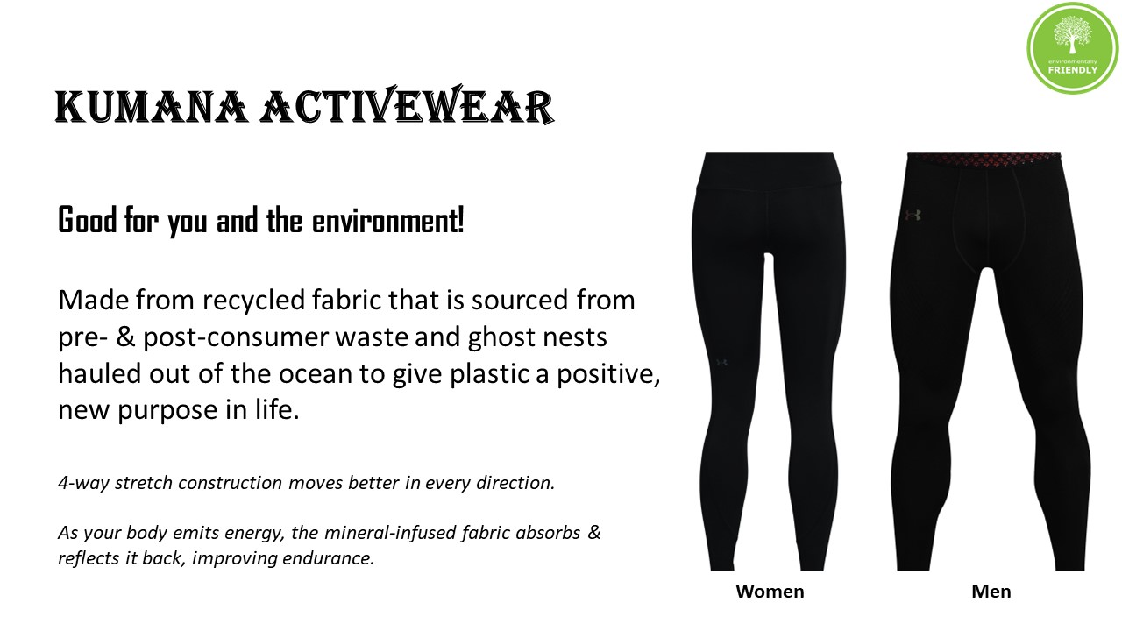

WEB APPENDIX B. MEASURES USED IN EACH STUDY
STUDY 2.
Manipulation Check for Nostalgia: Perceived Nostalgia (1 = strongly disagree, 7 = strongly agree, Wildschut et al. 2006)
I feel nostalgic at this moment.
Right now, I am feeling quite nostalgic.
Right now, I am having nostalgic feelings.
Manipulation Check for Stimuli: (1 = strongly disagree, 7 = strongly agree)
This ad focuses more on sustainable attributes.
This ad focuses more on the product benefits.
Mediator: Social Connectedness (1 = strongly disagree, 7 = strongly agree, Wildschut et al. 2006)
Thinking about this event makes me feel protected.
Thinking about this event makes me feel loved.
Thinking about this event makes me feel connected to loved ones.
Emotion Self-reported Measures: Full PANAS scale (1 = very slightly or not at all, 5 = extremely, Watson, Clark, and Tellegen 1988)
Positive emotions: Interest, Excited, Strong, Enthusiastic, Proud, Alert, Inspired, Determined, Attentive, Active.
Negative emotions: Distressed, Upset, Guilty, Scared, Hostile, Irritable, Ashamed, Nervous, Jittery, Afraid.
Meaning in Life: (1 = absolutely untrue, 7 = absolutely true, Steger et al. 2006)
I understand my life’s meaning.
I am looking for something that makes my life feel meaningful.
I am always looking to find my life’s purpose.
My life has a clear sense of purpose.
I have a good sense of what makes my life meaningful.
I have discovered a satisfying life purpose.
I am always searching for something that makes my life feel significant.
I am seeking a purpose or mission for my life.
My life has no clear purpose. (*reverse-coded)
I am searching for meaning in my life.
Covariate: Familiarity with Green Products (1 = strongly disagree, 7 = strongly agree, Lin and Chang 2012)
I am familiar with green products.
I am knowledgeable about green products.
Dependent Measure: Behavioral Intention (Peloza et al. 2013)
How inclined would you be to purchase the product? (1 = not very inclined, 7 = very inclined)
How likely would you be to purchase the product? (1 = very unlikely, 7 = very likely)
How willing would you be to purchase the product? (1 = very unwilling, 7 = very willing)
STUDY 3.
Manipulation Check for Nostalgia: Perceived Nostalgia
I feel nostalgic at this moment. (1 = strongly disagree, 7 = strongly agree, Wildschut et al. 2006)
Right now, I am feeling quite nostalgic. (1 = strongly disagree, 7 = strongly agree, Wildschut et al. 2006)
Right now, I am having nostalgic feelings. (1 = strongly disagree, 7 = strongly agree, Wildschut et al. 2006)
How much do you feel longing for the past? (1 = not at all, 7 = very much, New for Study 2)
Manipulation Check for Stimuli: (1 = strongly disagree, 7 = strongly agree)
This ad focuses more on sustainable attributes.
This ad focuses more on the product benefits.
This ad focuses more on functionality, usefulness, and practicality. (New for Study 2)
This ad focuses more on enjoyability, excitement, and fun. (New for Study 2)
Mediatior: Social Connectedness (1 = strongly disagree, 7 = strongly agree, Wildschut et al. 2006)
Thinking about this event makes me feel protected.
Thinking about this event makes me feel loved.
Thinking about this event makes me feel connected to loved ones.
Emotion Self-reported Measures: Short-form PANAS scale (1 = very slightly or not at all, 5 = extremely, I-PANAS-SF, Thompson 2007)
Positive emotions: Alert, Inspired, Determined, Attentive, Active.
Negative emotions: Upset, Hostile, Ashamed, Nervous, Afraid.
Covariate: Environmental Consciousness (1 = strongly disagree, 7 = strongly agree, Dunlap and Van Liere 2008)
We are approaching the limit of the number of people the Earth can support.
The balance of nature is very delicate and easily upset.
Humans have the right to modify the natural environment to suit their needs. (*reverse-coded)
Mankind was created to rule over the rest of nature. (*reverse-coded)
When humans interfere with nature it often produces disastrous consequences.
Plants and animals exist primarily to be used by humans. (*reverse-coded)
To maintain a healthy economy, we will have to develop a “steady-state” economy where industrial growth is controlled.
Humans must live in harmony with nature in order to survive.
The Earth is like a spaceship with only limited room and resources.
Humans need not adapt to the natural environment because they can remake it to suit their needs. (*reverse-coded)
There are limits to growth beyond which our industrialized society cannot expand.
Mankind is severely abusing the environment.
Covariate: Familiarity with Green Products (1 = strongly disagree, 7 = strongly agree, Lin and Chang 2012)
I am familiar with green products.
I am knowledgeable about green products.
Dependent Measure: Behavioral Intention (Peloza et al. 2013)
How inclined would you be to purchase the product? (1 = not very inclined, 7 = very inclined)
How likely would you be to purchase the product? (1 = very unlikely, 7 = very likely)
How willing would you be to purchase the product? (1 = very unwilling, 7 = very willing)
STUDY 4.
Manipulation Check for Nostalgia: Perceived Nostalgia (1 = strongly disagree, 7 = strongly agree, Wildschut et al. 2006)
I feel nostalgic at this moment.
Right now, I am feeling quite nostalgic.
Right now, I am having nostalgic feelings.
Mediator: Social Connectedness (1 = strongly disagree, 7 = strongly agree, Wildschut et al. 2006)
Thinking about this event makes me feel protected.
Thinking about this event makes me feel loved.
Thinking about this event makes me feel connected to loved ones.
Dependent Measure 1: Behavioral Intention (Peloza et al. 2013)
How inclined would you be to purchase the product? (1 = not very inclined, 7 = very inclined)
How likely would you be to purchase the product? (1 = very unlikely, 7 = very likely)
How willing would you be to purchase the product? (1 = very unwilling, 7 = very willing)
Dependent Measure 2: Support for Increased Government Funding for R&D
Kumo needs financial support from the government for its Research & Development. To what extent do you support increasing state funding for research on Kumo’s apparel products? (1 = not at all, 7 = very much)
Moderator: Environmental Consciousness (1 = strongly disagree, 7 = strongly agree, Dunlap and Van Liere 2008)
We are approaching the limit of the number of people the Earth can support.
The balance of nature is very delicate and easily upset.
Humans have the right to modify the natural environment to suit their needs. (*reverse-coded)
Mankind was created to rule over the rest of nature. (*reverse-coded)
When humans interfere with nature it often produces disastrous consequences.
Plants and animals exist primarily to be used by humans. (*reverse-coded)
To maintain a healthy economy, we will have to develop a “steady-state” economy where industrial growth is controlled.
Humans must live in harmony with nature in order to survive.
The Earth is like a spaceship with only limited room and resources.
Humans need not adapt to the natural environment because they can remake it to suit their needs. (*reverse-coded)
There are limits to growth beyond which our industrialized society cannot expand.
Mankind is severely abusing the environment.
STUDY 5.
Manipulation Check for Social-Connectedness Task:
How difficult was it to generate the list of three people as above? (1 = extremely easy, 7 = extremely difficult)
To what extent would you use the term we to describe your relationship with the people you listed? (1 = not at all, 7 = very much)
Please select the pair in the “Inclusion of Other in the Self Scale” that best describes your relationship with the Person #1/#2/#3 you listed and write the number in the box below (7-point scale).
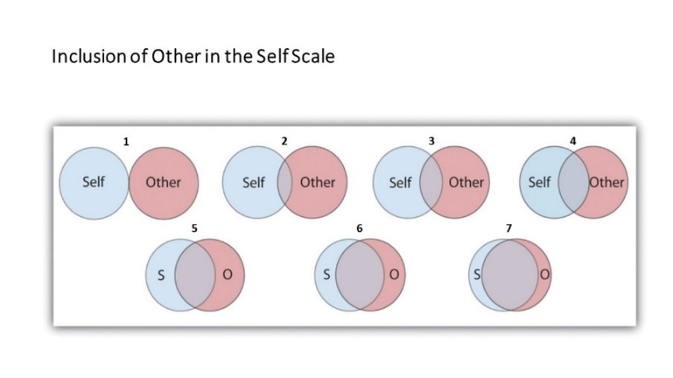
Perceived Social Connectedness (1 = not at all, 7 = very much, McFerran and Argo 2014)
Right now, I feel connected.
Right now, I feel like part of a group.
Right now, I feel like I belong.
Right now, I feel like I fit in.
Right now, I feel popular.
Right now, I feel well-liked.
Right now, I feel united with others.
I feel lonely at the moment.
Manipulation Check for Nostalgia: Perceived Nostalgia
I feel nostalgic at this moment. (1 = strongly disagree, 7 = strongly agree, Wildschut et al. 2006)
Right now, I am feeling quite nostalgic. (1 = strongly disagree, 7 = strongly agree, Wildschut et al. 2006)
Right now, I am having nostalgic feelings. (1 = strongly disagree, 7 = strongly agree, Wildschut et al. 2006)
How much do you feel longing for the past? (1 = not at all, 7 = very much)
Dependent Measure: Behavioral Intention (Peloza et al. 2013)
How inclined would you be to purchase the product? (1 = not very inclined, 7 = very inclined)
How likely would you be to purchase the product? (1 = very unlikely, 7 = very likely)
How willing would you be to purchase the product? (1 = very unwilling, 7 = very willing)
Please indicate the percentage below or above market price you would be willing to pay for this product (1 = less than 30% below market price, 7 = more than 30% above market price).
How much are you willing to pay for this product? (from USD$0 to $200)
Manipulation Check for Stimuli: (1 = strongly disagree, 7 = strongly agree)
This ad focuses more on sustainable attributes.
This ad focuses more on the product benefits.
This ad focuses more on functionality, usefulness, and practicality.
This ad focuses more on enjoyability, excitement, and fun.
POST-HOC STUDY
Take a moment to think about the risks associated with purchasing a product from Kumo's Activewear Collection. Please respond to the following statements as truthfully and accurately as you can, and also please remember that these are very subjective questions and that there are no right or wrong answers.
Overall Risk (1 = strongly disagree, 7 = strongly agree):
Overall, the thought of buying a product from this Kumo's Activewear Collection makes me concerned about experiencing some kind of loss if I go through with the purchase.
All things considered, I think I would be making a mistake if I were to buy a product from this Kumo's Activewear Collection.
When all is said and done, I feel that purchasing a product from this Kumo's Activewear Collection poses problems I simply don’t need.
Performance risk (1 = strongly disagree, 7 = strongly agree):
I worry about whether the product will perform as well as expected.
I am concerned that the product will not provide the benefits I expected.
I am concerned about how dependable and reliable the product will be.
Financial risk (1 = strongly disagree, 7 = strongly agree):
I am concerned that it may be a bad way to spend my money.
I am concerned that it may be expensive.
I am concerned about not getting my money’s worth.
Psychological risk (1 = strongly disagree, 7 = strongly agree):
I am concerned that it causes me psychologically discomfort.
I am concerned that it causes me unwanted anxiety.
I am concerned that it causes me unnecessary tension.
Physical risk (1 = strongly disagree, 7 = strongly agree):
I am concerned that the product could be contaminated and transmit diseases.
I am concerned that the product could cause uncomfortable physical side effects.
I am concerned about potential physical risks associated with this product, as it may not be completely safe.
Social risk (1 = strongly disagree, 7 = strongly agree):
I don’t think my associates at work would hold me in higher esteem.
I am concerned that some friends might think I am just being showy.
I am concerned that some people whose opinions I value might think I am foolish.
WEB APPENDIX C. RULE OUT ALTERNATIVE ACCOUNTS IN STUDY 3
Similar to Study 2, we found that alternative explanations, such as social processes, affiliation motivation, positive emotions, and sentiments, could not account for the observed relationship between nostalgia and sustainable apparel adoption. For brevity, the detailed analysis ruling out these alternative explanations is available in Appendix C. LIWC revealed that narratives about nostalgic photographs (vs. ordinary events) contained more words relating to social process (M_{Nostalgia} = 10.66, SD = 5.89; M_{Control} = 5.55, SD = 5.34, t(624) = 11.39, p < .001, Cohen’s d = .91) and affiliation motivation (M_{Nostalgia} = 5.81, SD = 5.46; M_{Control} = 2.62, SD = 3.91, t(624) = 8.34, p < .001, Cohen’s d = .68). Participants in the nostalgia (vs. control) condition also scored higher in positive emotions detected by LIWC (M_{Nostalgia} = 6.44, SD = 4.68; M_{Control} = 4.56, SD = 4.24, t(624) = 5.27, p < .001, Cohen’s d = .42) and positive sentiments detected by VADER (M_{Nostalgia} = .20, SD = .11; M_{Control} = .14, SD = .10, t(624) = 6.95, p < .001, Cohen’s d = .56).
PROCESS Model 4 (Hayes 2018) revealed non-significant indirect effects going through social process (95% CI [-.01, .38]), affiliation motivation (95% CI [-.01, .28]), and positive emotions (95% CI [-.05, .13]). However, the indirect effect going through positive sentiments was significant (b = .10, 95% CI [.00, .22]). We then conducted PROCESS Model 6 (Hayes 2018) with perceived social connectedness and positive sentiments included as parallel mediators. The indirect effect going through perceived social connectedness was significant (b = .55, 95% CI [.29, .83]), while the indirect effect going through positive sentiments became non-significant (95% CI [-.05, .14]). Therefore, these alternative accounts cannot explain the effect.

